ECSE-200 Electric Circuits 1 - Quiz #11 (April 5, 2019)

**LAST NAME** ______________________________________________ **MCGILL ID#** __________________

**FIRST NAME­­­­­­­­­**________________________________**SIGNATURE**_________________________________

* ***Only Faculty standard calculator accepted***
* ***No cellphone allowed***
* ***Show all your work***
* ***Clearly indicate your final answer with the SI unit and multiplier***
* ***You have 45 minutes to complete this quiz***

**__________________________________________________________________________________________**

**Question 1:** Consider the circuit shown. The switch opens the connection at $t=0 s$. The circuit reaches steady state before the switch changes its connection state. Answer the following questions.

1. **A screenshot of a cell phone

   Description automatically generated**Find the solution of the current $i_{L}\left(t\right)$ for $t>0 s$. [3 pt]
2. Plot the current $i_{L}\left(t\right)$ with respect to time *t* indicating the time constant, the initial and final current values. [2 pt]
3. Find the voltage $v_{x}\left(t\right)$ for $t>0 s$. [2 pt]

Extra Working Space

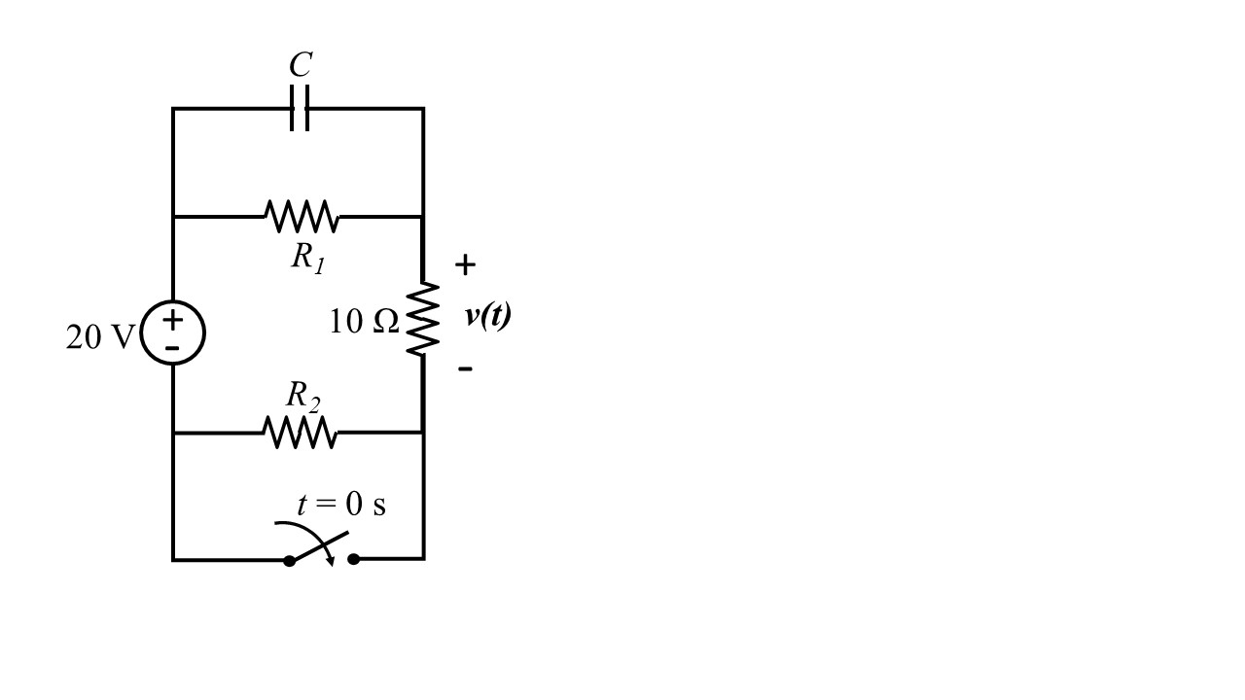**Question 2:** Consider the circuit shown. The switch closes and makes the connection at time *t* = 0 s. The circuit reaches steady state before the switch changes its connection.

The voltage across the 10 Ω resistor as shown in the circuit is

$$v\left(t\right)=6+3e^{-2t} V for t>0 s$$

Answer the following questions.

1. Determine the time constant of this circuit. [1 pt]
2. Find *R1*, *R2*, and C. [3 pt]
3. Determine the energy stored in the capacitor at *t* = 0s. [2 pt]

Extra Working Space